

**SCHOOL OF COMPUTER SCIENCES UNIVERSITI SAINS MALAYSIA**

**CAT201: Integrated Software Development Workshop**

**Semester II, Academic Session : 2023/2024**

**Final Report *Group Number 31***

***Lecturer’s Name : Dr. Zurinahni Zainol***

***Project Title : USM Bank Account Management System***

| **Names** | **Matric No** | **USM Email Address** | **Module** | **Role** |
| --- | --- | --- | --- | --- |
| MOHSIN ALI | 165381 | **20july2003mohsin@student.usm.my** | **1 and 2** | **Leader** |
| AZAM TAMHEED | 160610 | **azamtamheed@student.usm.my** | **2 and 3** | **Member** |
| **A**bdelrahman Hamdy Fergany | 160703 | **abdelrahman@student.usm.my** | **4** | **Member** |
| Masood Abdulrahman Abdullah saeed | 160233 | **masood@student.usm.my** | **5** | **Member** |

**Date of submission: 21 Jan 2024**

**Table of Contents**

**1.0 Introduction____________________________________________________________ 3 2.0 Requirements___________________________________________________________ 4**

**3.0 Business Rules__________________________________________________________ 7 4.0 Front-end System and Implementation______________________________________8 4.1 Graphical User Interfaces Design and User interface storyboard _______________**

**4.2 Module design and diagram for each module________________________________ 25**

**5.0 Project problems and pitfalls_____________________________________________ 27**

**6.0 Conclusions, Recommendations and Future Works__________________________ 29**

**7.0 References____________________________________________________________ 30**

1. **Introduction**

In the dynamic and evolving landscape of higher education, the unique and ever-changing financial needs and habits of university students call for a banking system that aligns seamlessly with their lifestyles. The University Bank Account Management System (UBAMS) emerges as a pioneering solution to this need, specifically tailored for the university student demographic. Representing a significant paradigm shift from traditional banking methods to a more digital-first approach, UBAMS offers a comprehensive range of services designed to meet the diverse financial needs of the student population. This innovative system extends beyond being a mere financial platform; it plays a critical role in supporting students on their educational journey.

At the heart of UBAMS is an acute understanding of the challenges faced by students in managing their finances, balancing academic responsibilities, and often juggling part-time work. Conventional banking models, typically crafted for a broader audience, fall short in addressing these specific challenges faced by students. In response, UBAMS is conceptualized with a focus on user-centricity, ensuring ease of navigation, accessibility, and robust security, making it a perfect fit for students with varied levels of financial and digital literacy.

Furthermore, UBAMS closely aligns with the Sustainable Development Goal 4: Quality Education as set forth by the United Nations. This goal emphasizes the importance of inclusive and equitable quality education and the promotion of lifelong learning opportunities. UBAMS contributes to this goal by offering a streamlined and intuitive banking system, significantly alleviating financial stress among students, thus indirectly bolstering their academic success and retention in higher education. Financial well-being is a critical component of a student's ability to focus and engage effectively in their studies.

UBAMS also boasts of seamless integration into the university ecosystem. This integration encompasses interfacing with various university administrative and financial systems, thereby providing a unified and cohesive experience for students. This feature is crucial in ensuring that students can efficiently manage not only their personal finances but also effectively interact with university-related financial matters, including tuition payments, financial aid, and scholarship management.

Developed using Java, a versatile programming language, UBAMS capitalizes on advanced technologies to streamline and accelerate banking processes, which are often slow and cumbersome in manual systems. A significant challenge in IT and system development projects like UBAMS is the effective creation and management of requirements. Addressing this, UBAMS places a strong emphasis on meticulously defining and managing these requirements to ensure alignment with the specific needs of university students, while adhering to compliance standards and maintaining budget and schedule constraints.

A key feature of UBAMS is its dual design as both an interactive and content management platform. The content management aspect focuses on data entry, validation, and updating, while the interactive component facilitates seamless interaction between the system, its administrators, and student users. This approach ensures that UBAMS is not only efficient in transaction processing but also excels in maintaining relevant and accurate information, thereby enhancing the overall efficiency and user experience for university students.

Incorporating various methods such as account number generation, offering different account types, real-time balance maintenance and updates, and facilitating easy account operations and transactions, UBAMS stands as a beacon of innovation in university-specific banking. It streamlines financial management for students, significantly contributing to their educational and personal life management. This system's comprehensive bank management software is designed to ensure efficient tracking of properties and transactions, focused on customer satisfaction, time efficiency, customer protection, and ease of money transfer.

**2. Requirements**

The development of the University Bank Account Management System (UBAMS) involves implementing a range of functionalities that cater to the banking needs of university students and staff. Below are the outlined methods and corresponding requirements necessary for the UBAMS report:

**Functionalities of the UBAMS:**

**1. Secure Authentication:**

- For Users: Secure login systems for students and staff with card numbers and PINs, possibly enhanced with multi-factor authentication to ensure that only authorized individuals can access their accounts.

- For Employees/Admins: A separate, more secure authentication mechanism for employees and administrators to access administrative functions.

**2. Account Management:**

- Personalized Dashboards: After login, users should reach a personalized dashboard that shows a summary of their account, including balance, recent transactions, and quick access to various features.

- Card Number Generation: The system should automatically generate a unique and secure bank account number for each user upon account creation.

**3. Transaction Services:**

- Deposits and Withdrawals: Users must be able to deposit and withdraw funds. The system should update balances in real-time and provide immediate transaction confirmations.

- Balance Inquiry: Users should be able to check their current balance through a simple interface.

- Mini Statements: The system should provide users with a mini-statement showing recent transactions and the current balance.

**4. Account Types:**

- Savings Account: For users who want to save money, with interest accruing on the balance.

- Current Account: For users who require frequent access to their funds for daily transactions, potentially with a checkbook or overdraft facility.

**5. User-Friendly Interface:**

- Intuitive Navigation: The application should feature an easy-to-navigate interface, allowing users to access all services without confusion.

- Accessibility: The design should be accessible to all users, including those with disabilities, and adhere to best practices in UI/UX design.

**6. Security and Compliance:**

- Data Protection:Safeguarding personal and financial data with encryption and other security best practices.

- Regulatory Compliance: Ensuring the system complies with financial regulations and university policies.

**7. Signup Page (Employee/Admin)**

- Requirement: An exclusive signup page for new employees or administrators should be implemented. This page should collect necessary information and go through a rigorous verification process to ensure authenticated access.

**8. Logout Functionality**

- Requirement: The system must include a secure and reliable logout feature. This feature is crucial for maintaining the security of the user’s account, especially when accessed from shared or public devices.

**3.Business Rules**

The University Bank Account Management System (UBAMS) is designed with a set of comprehensive business rules to ensure efficient, secure, and compliant operation. These rules are pivotal in guiding the system’s functionality and user interactions.

**-User Credentials Verification**: All user logins must be authenticated using valid credentials. The system shall reject any login attempts with invalid credentials.

-**Account Creation Security:** New user accounts can only be created following a secure signup process, which includes real-time data validation and confirmation of user details.

**-Confidentiality of Sensitive Information:** All sensitive user information, including passwords and personal data, must be securely handled and stored to prevent unauthorized access.

**-Unique Card Number Generation:** Each new account must be assigned a unique card number generated through a secure algorithm, ensuring the prevention of duplication and fraud.

**-Diverse Account Types Management:** The system shall support different types of accounts (e.g., Savings, Current) and apply specific rules and features to each.

**-Accurate and Real-Time Balance Reporting:** Account balances must be updated in real-time following any transaction to ensure accurate financial reporting.

**-Secure Transaction Processing:** All deposit and withdrawal transactions must be securely processed, ensuring the integrity and confidentiality of each transaction.

**-Accurate Transaction Records:** The system must maintain comprehensive and accurate records of all transactions for auditing and user reference purposes.

**-Fast Cash Transaction Handling**: Fast Cash withdrawals should be efficiently processed, adhering to preset withdrawal limits and security checks.

**-Intuitive Interface Design**: The user interface, especially for ATM transactions, must be intuitive, accessible, and easy to navigate for all users.

**-Consistency in Interface:** The visual design and layout of the interface screens should be consistent and clear across the system to avoid user confusion.

**-Secure Database Connectivity:** Database connections must be secure, reliable, and protected against unauthorized access.

-**Efficient Data Management:** Data retrieval and storage should be optimized for efficiency, ensuring quick and accurate access to account information.

-**Timely Notifications:** The system must send immediate email and SMS notifications to users following significant account activities or events.

**-Utility Function Efficiency:** Shared utility functions should be efficiently implemented to avoid redundancy and ensure consistent application functionality.

**4.Front-end System and Implementation**

**Graphical user interfaces design/User interface storyboard**

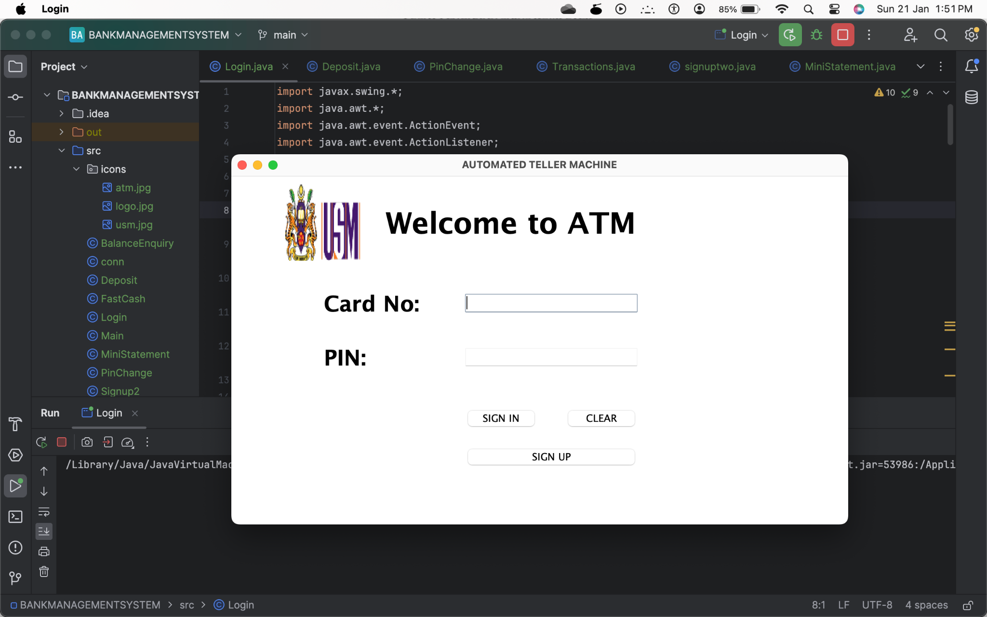

**login class**

**We can login using our card number and generated pincode.**

**If we do not have an account click on signup.**

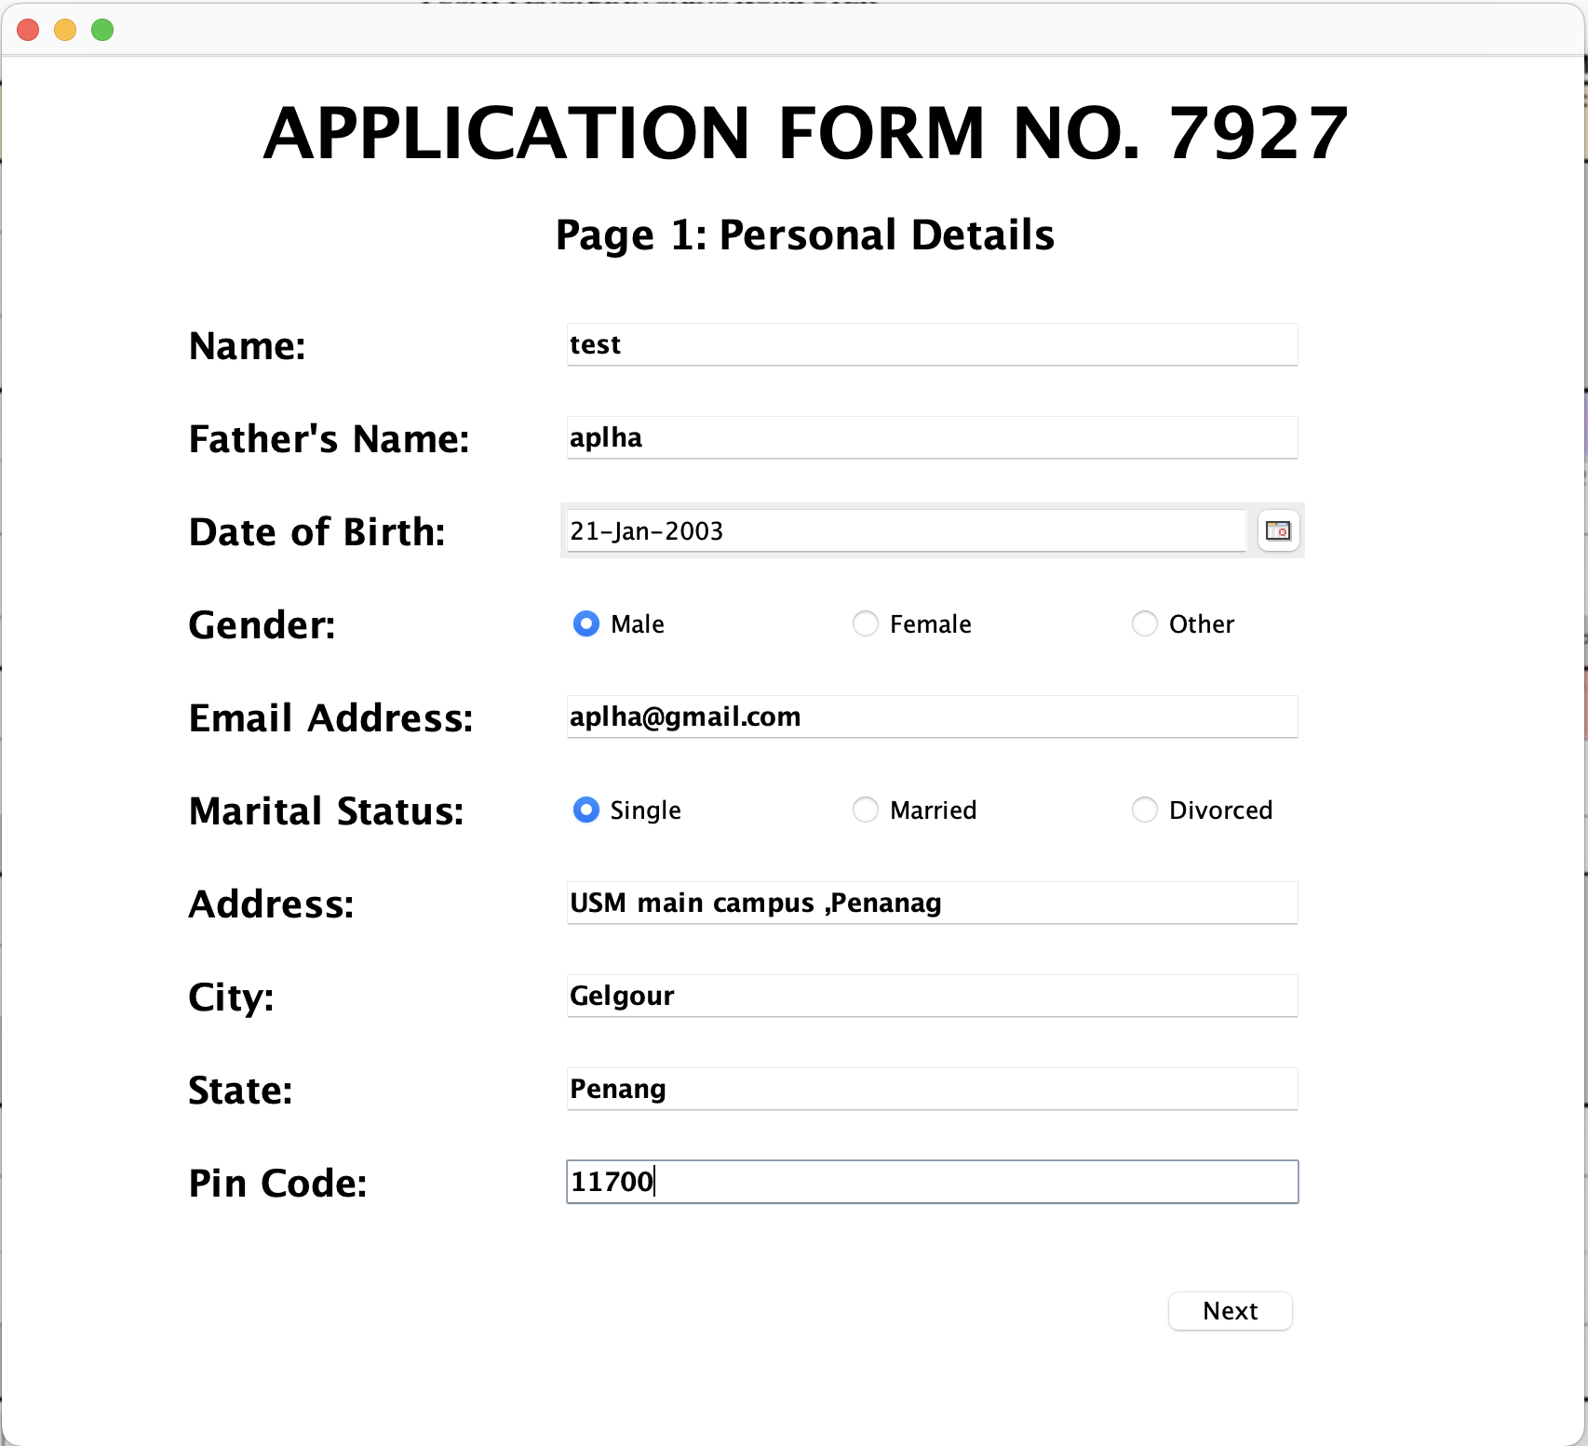

**signupone class:**

**First page of signup write basic details of the user.**

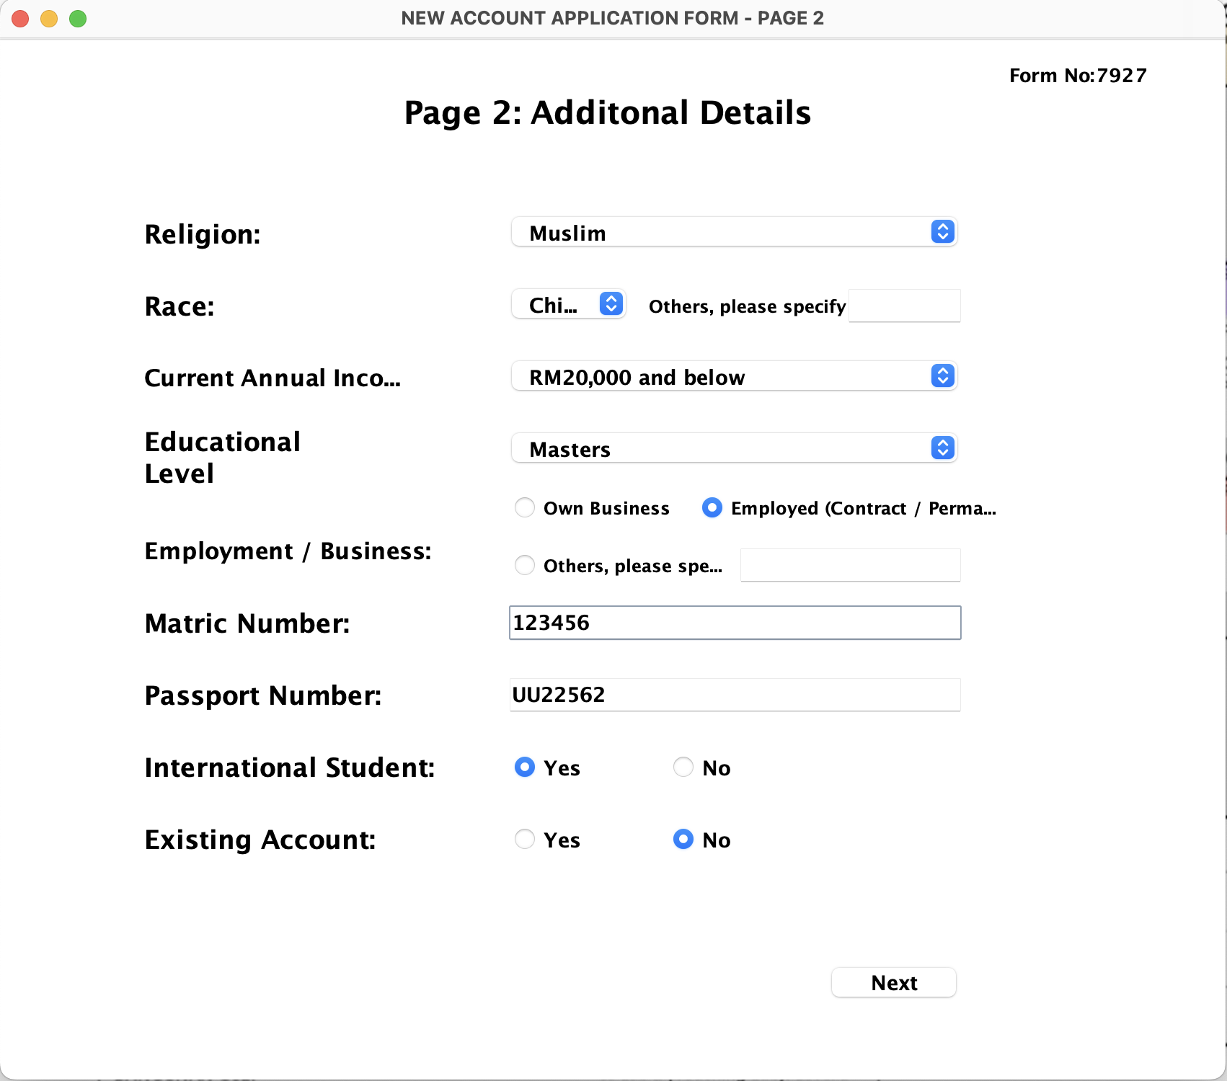

**signuptwo class:**

**Second page of signup to write advance details of user like religion, race and more.**

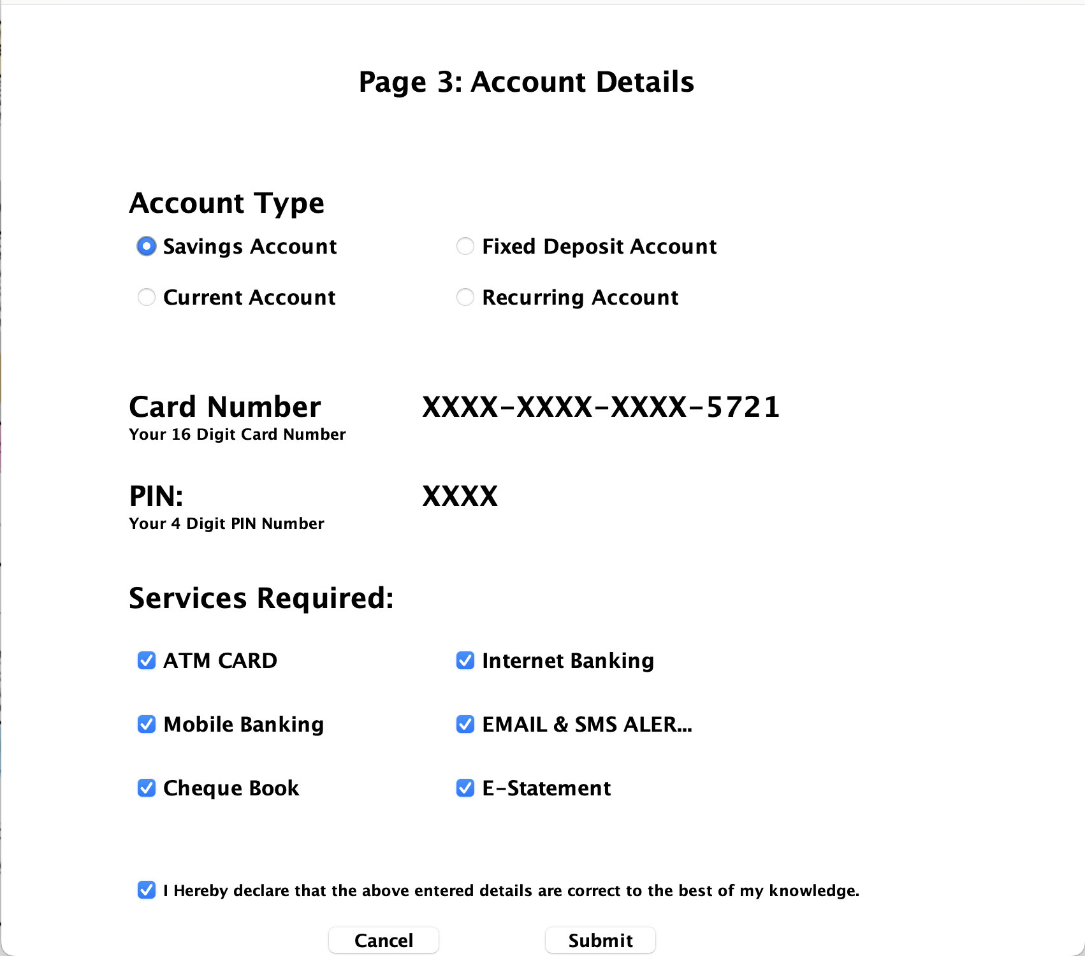

**singupthree class: Third page of signup where you will choose account type and services required.**

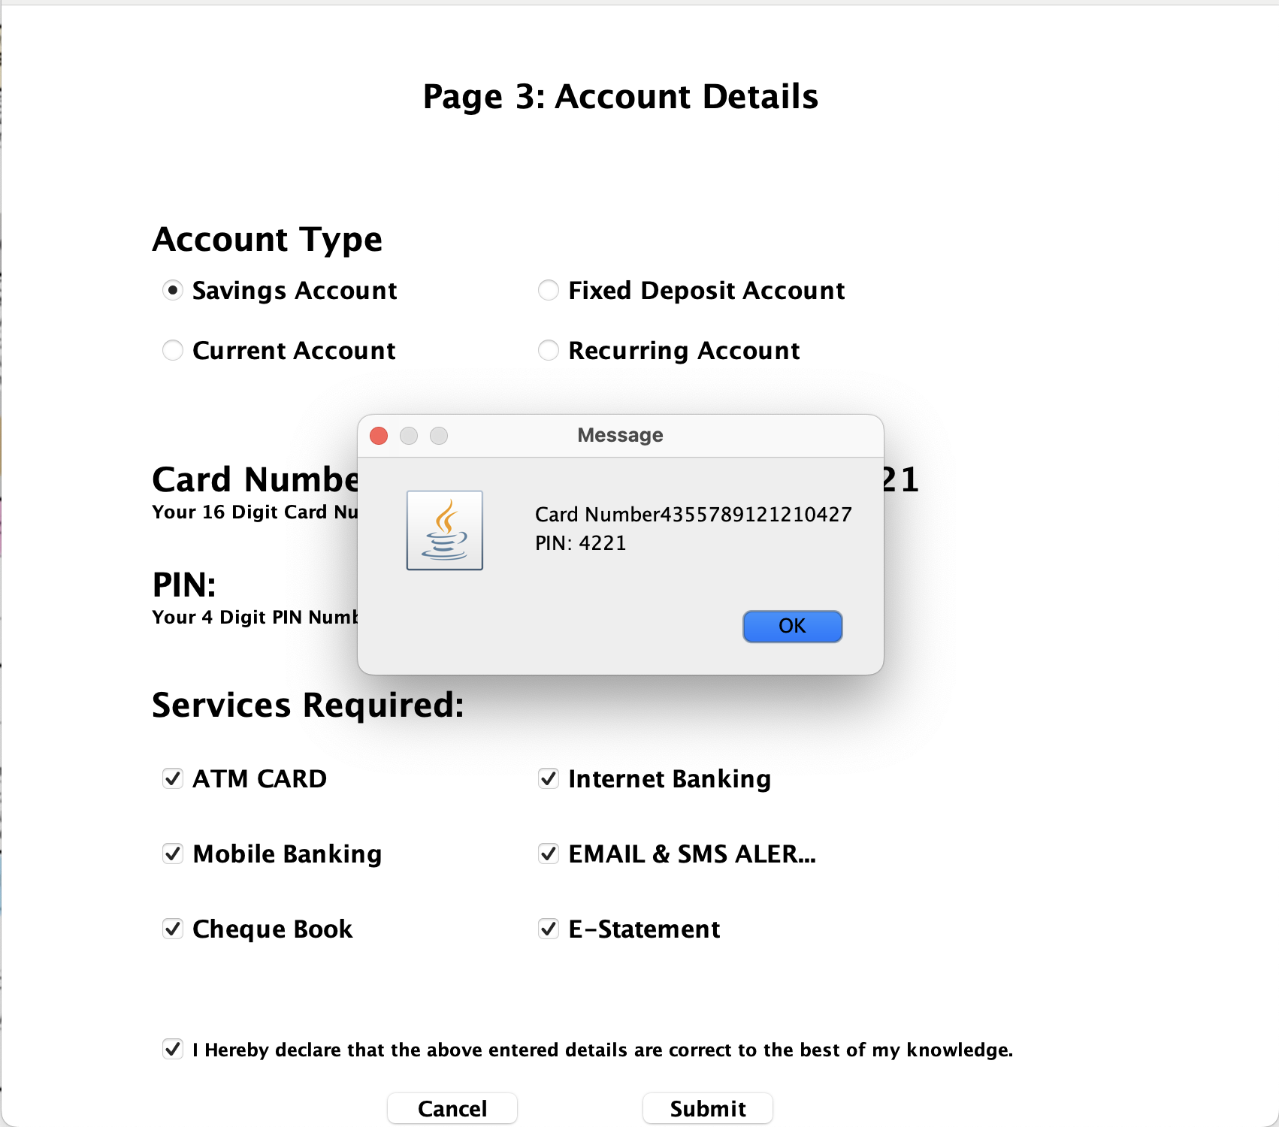

**signup three class:**

**Card Number and pin code generated.**

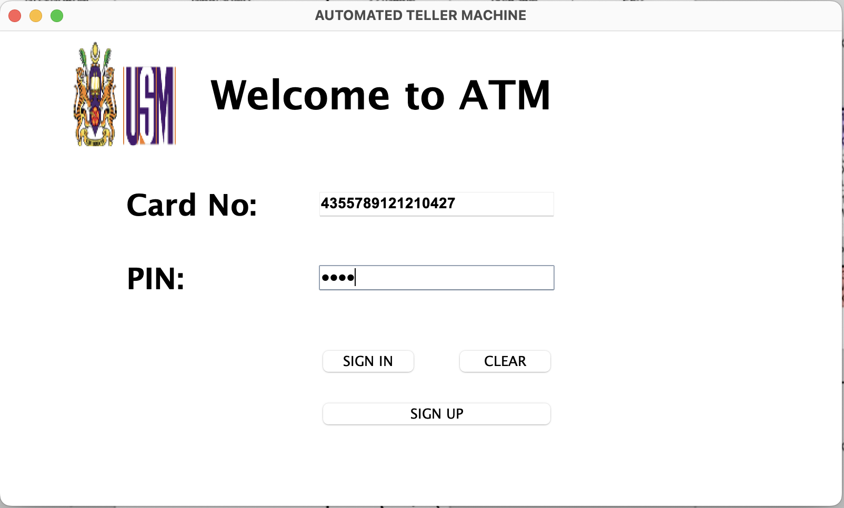

**login class:**

**After generating the card number and pin code login to the page.**

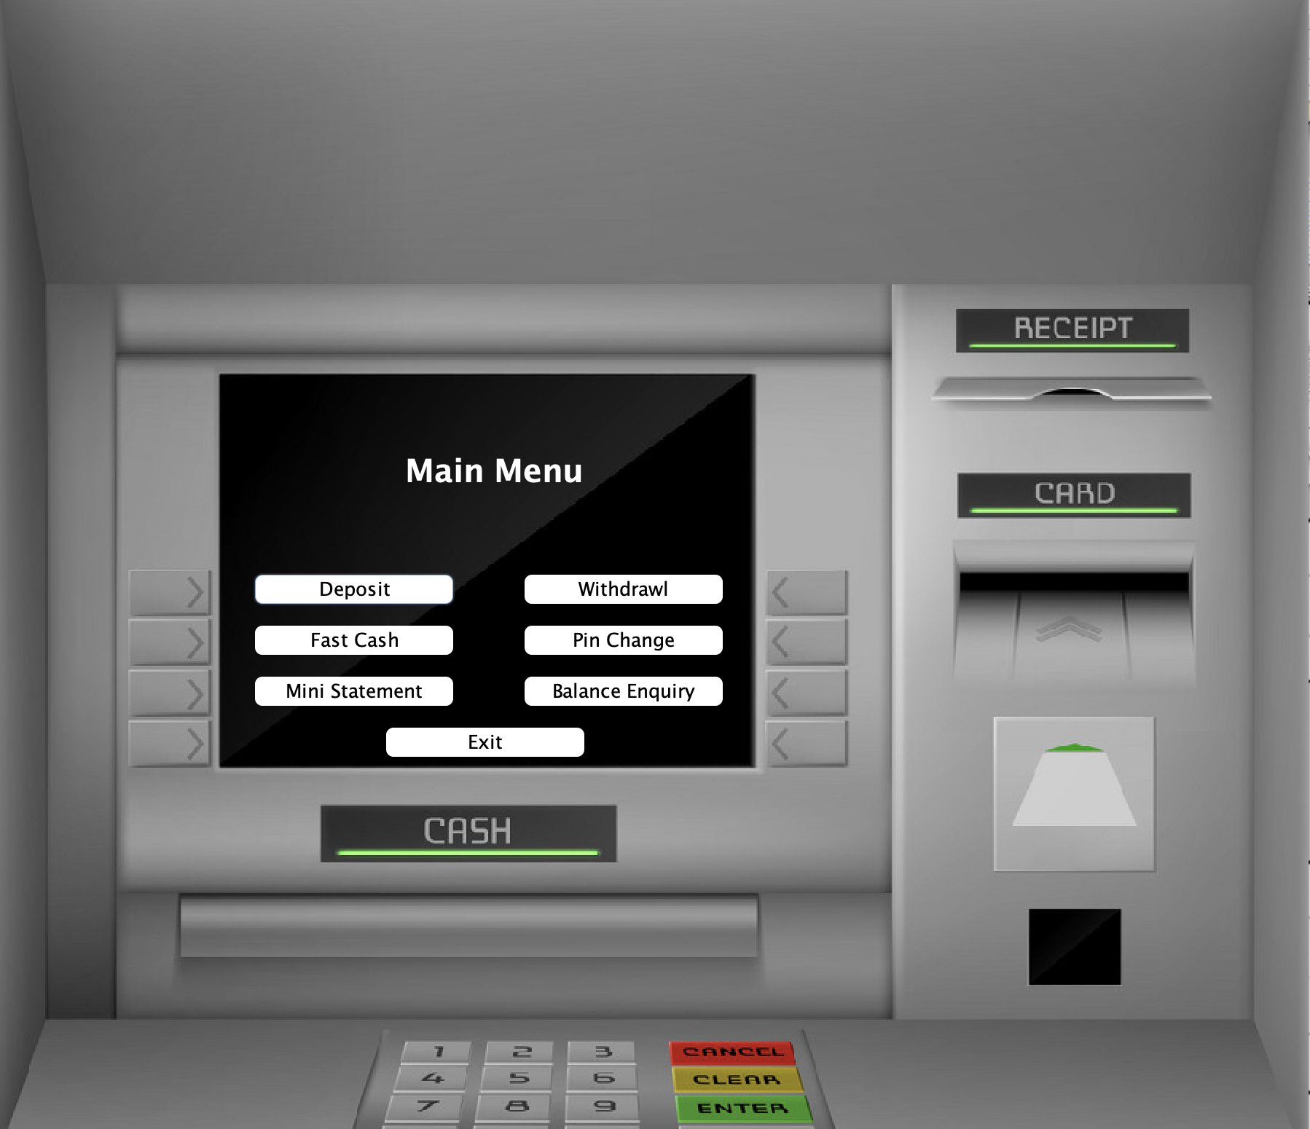

**transaction class:**

**It is the main menu where you can choose between different options like Deposit withdrawal mini statement balance enquiry and many more**

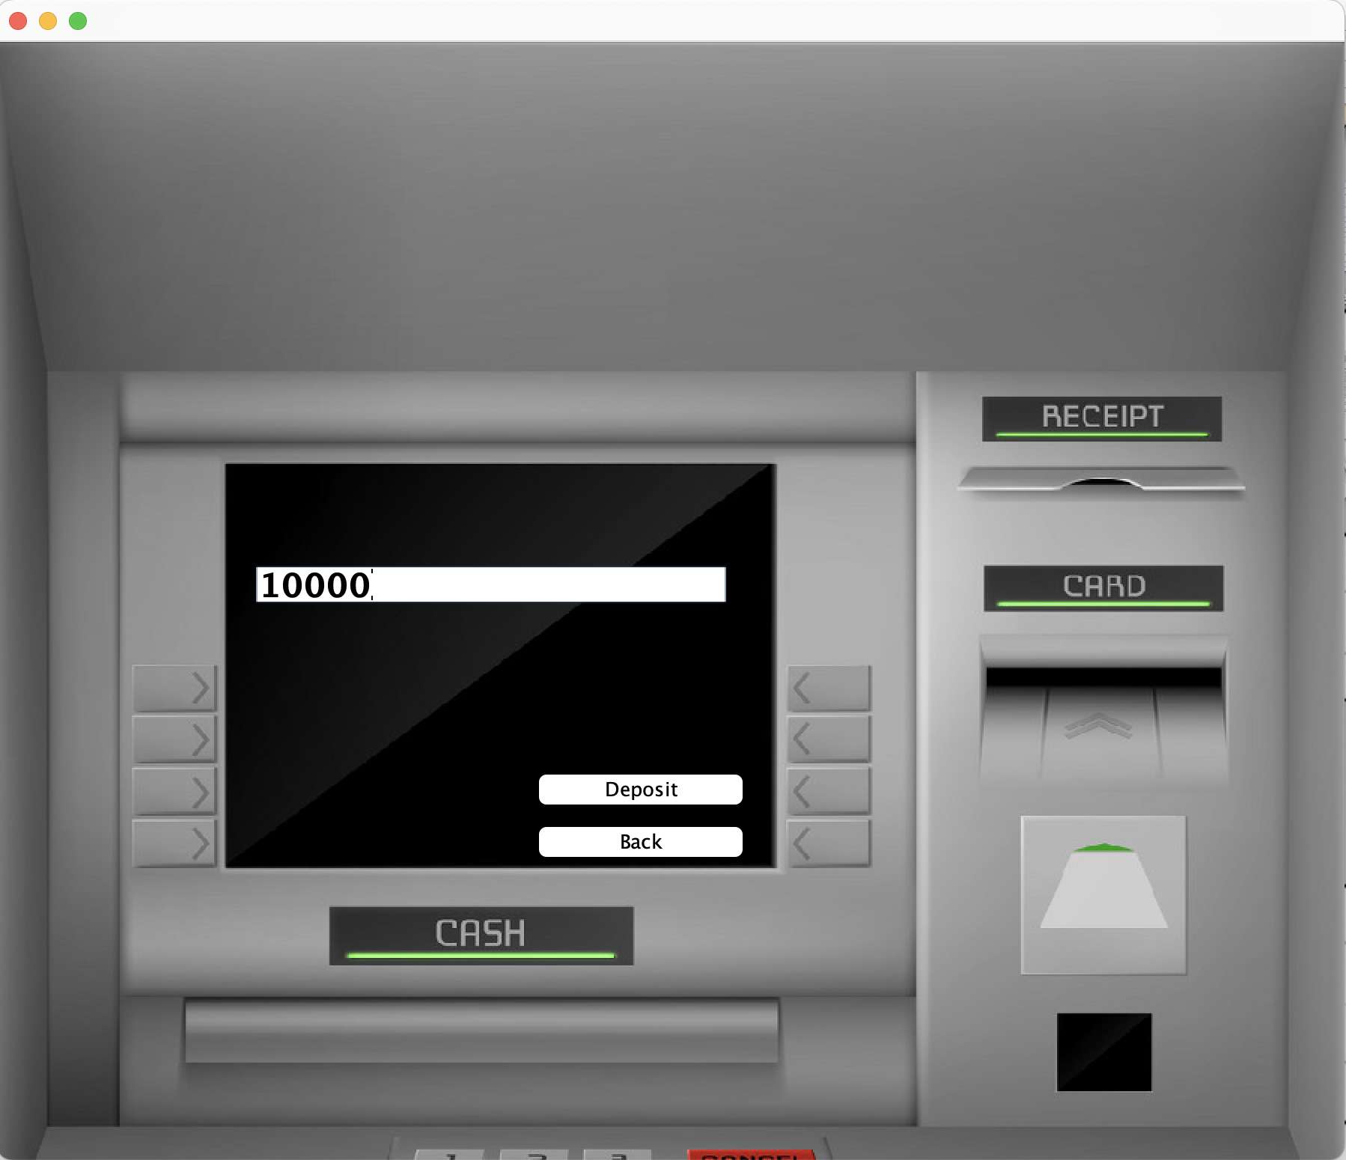

**deposit class:**

**Input the specific amount you want to deposit to your student account.**

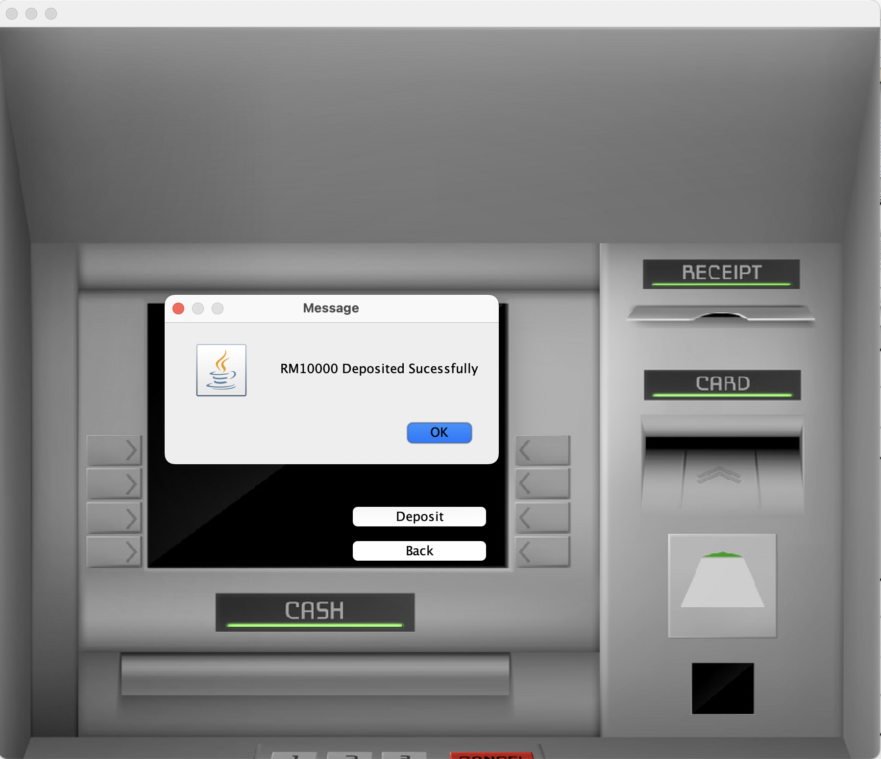

**deposit class:**

**After depositing the amount an message will pop up saying deposited successfully.**

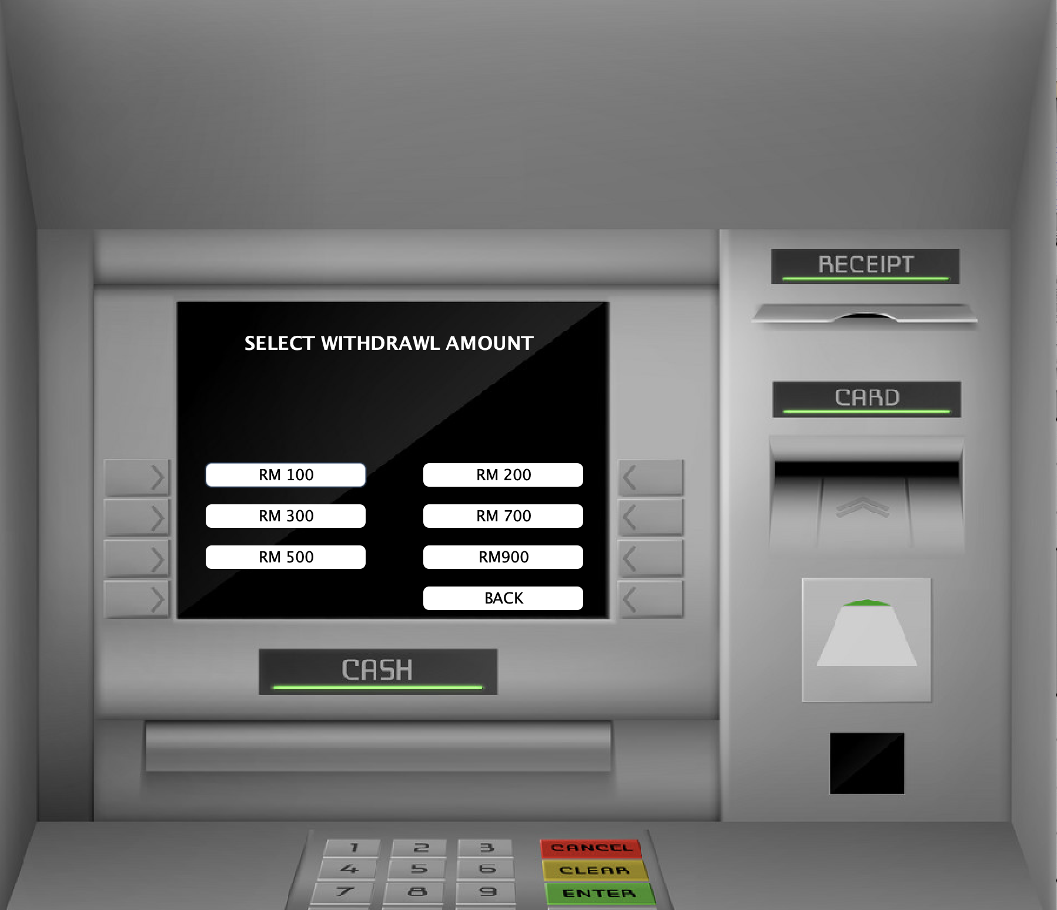

**fastcash class:**

**Users can choose between pre-set amounts to withdraw from the account.**

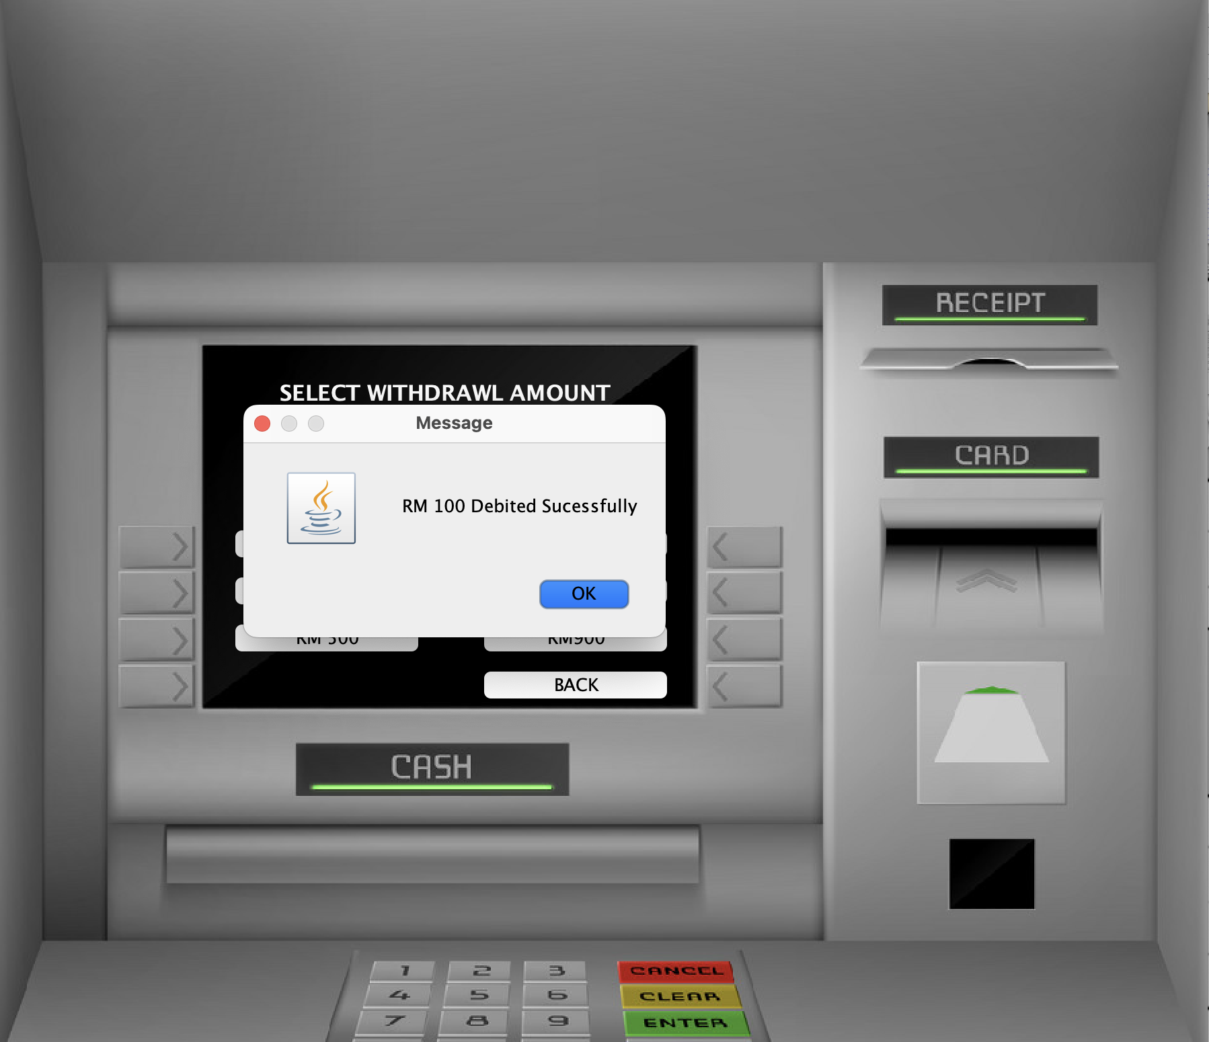

**fastcash class:**

**After selecting it will get a message saying amount debited successfully specifying the amount deducted.**

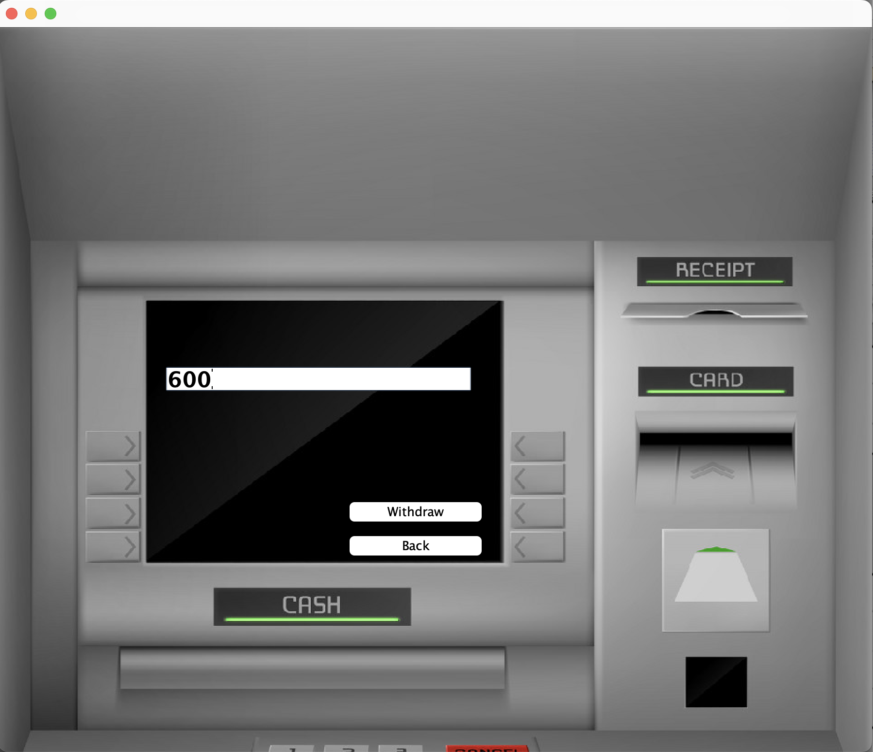

**withdrawal class:**

**To withdraw a specific amount from your student account.**

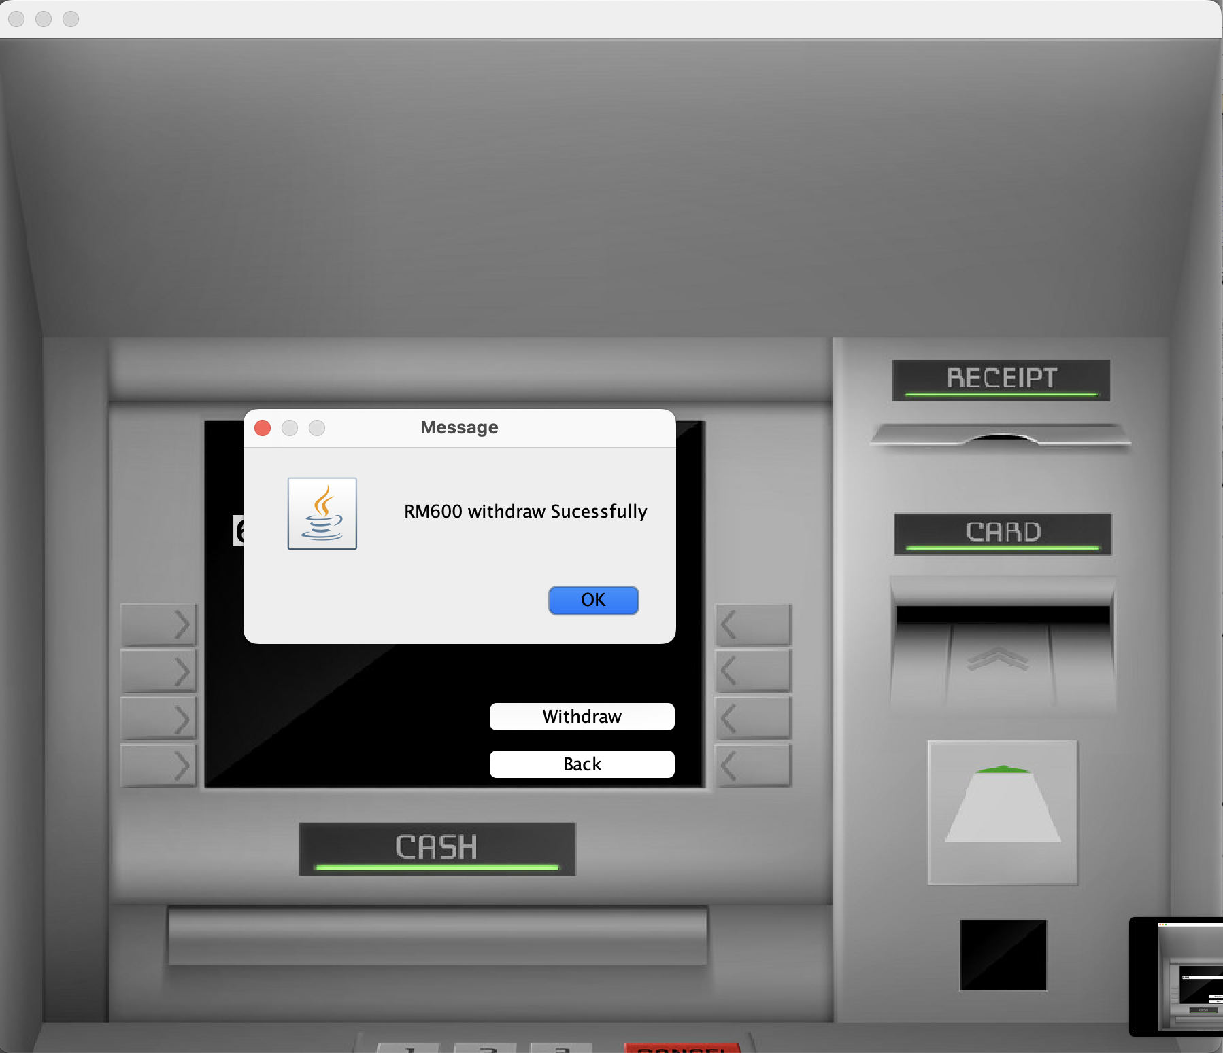

**withdrawal class:**

**After inputting the successful message will pop up.**



**balance enquiry class:**

**To display the amount left in the bank account at a specific time retrieving from the database.**

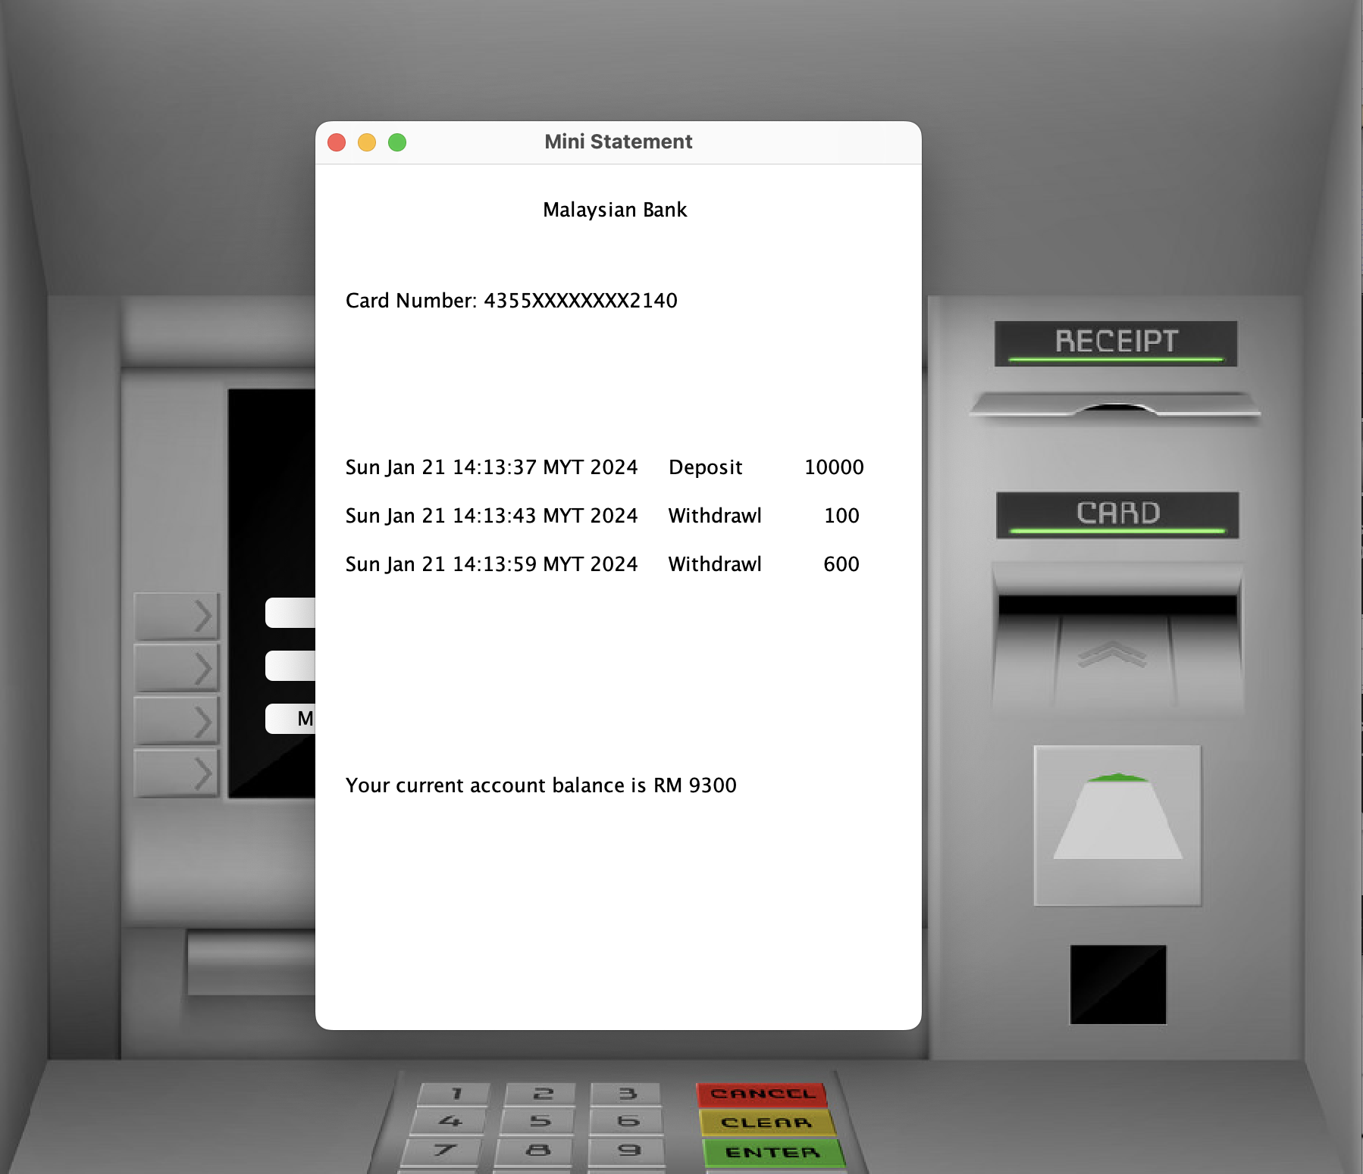

**mini statement class:**

**To display the transaction history of the user along with the remaining balance of the account.**

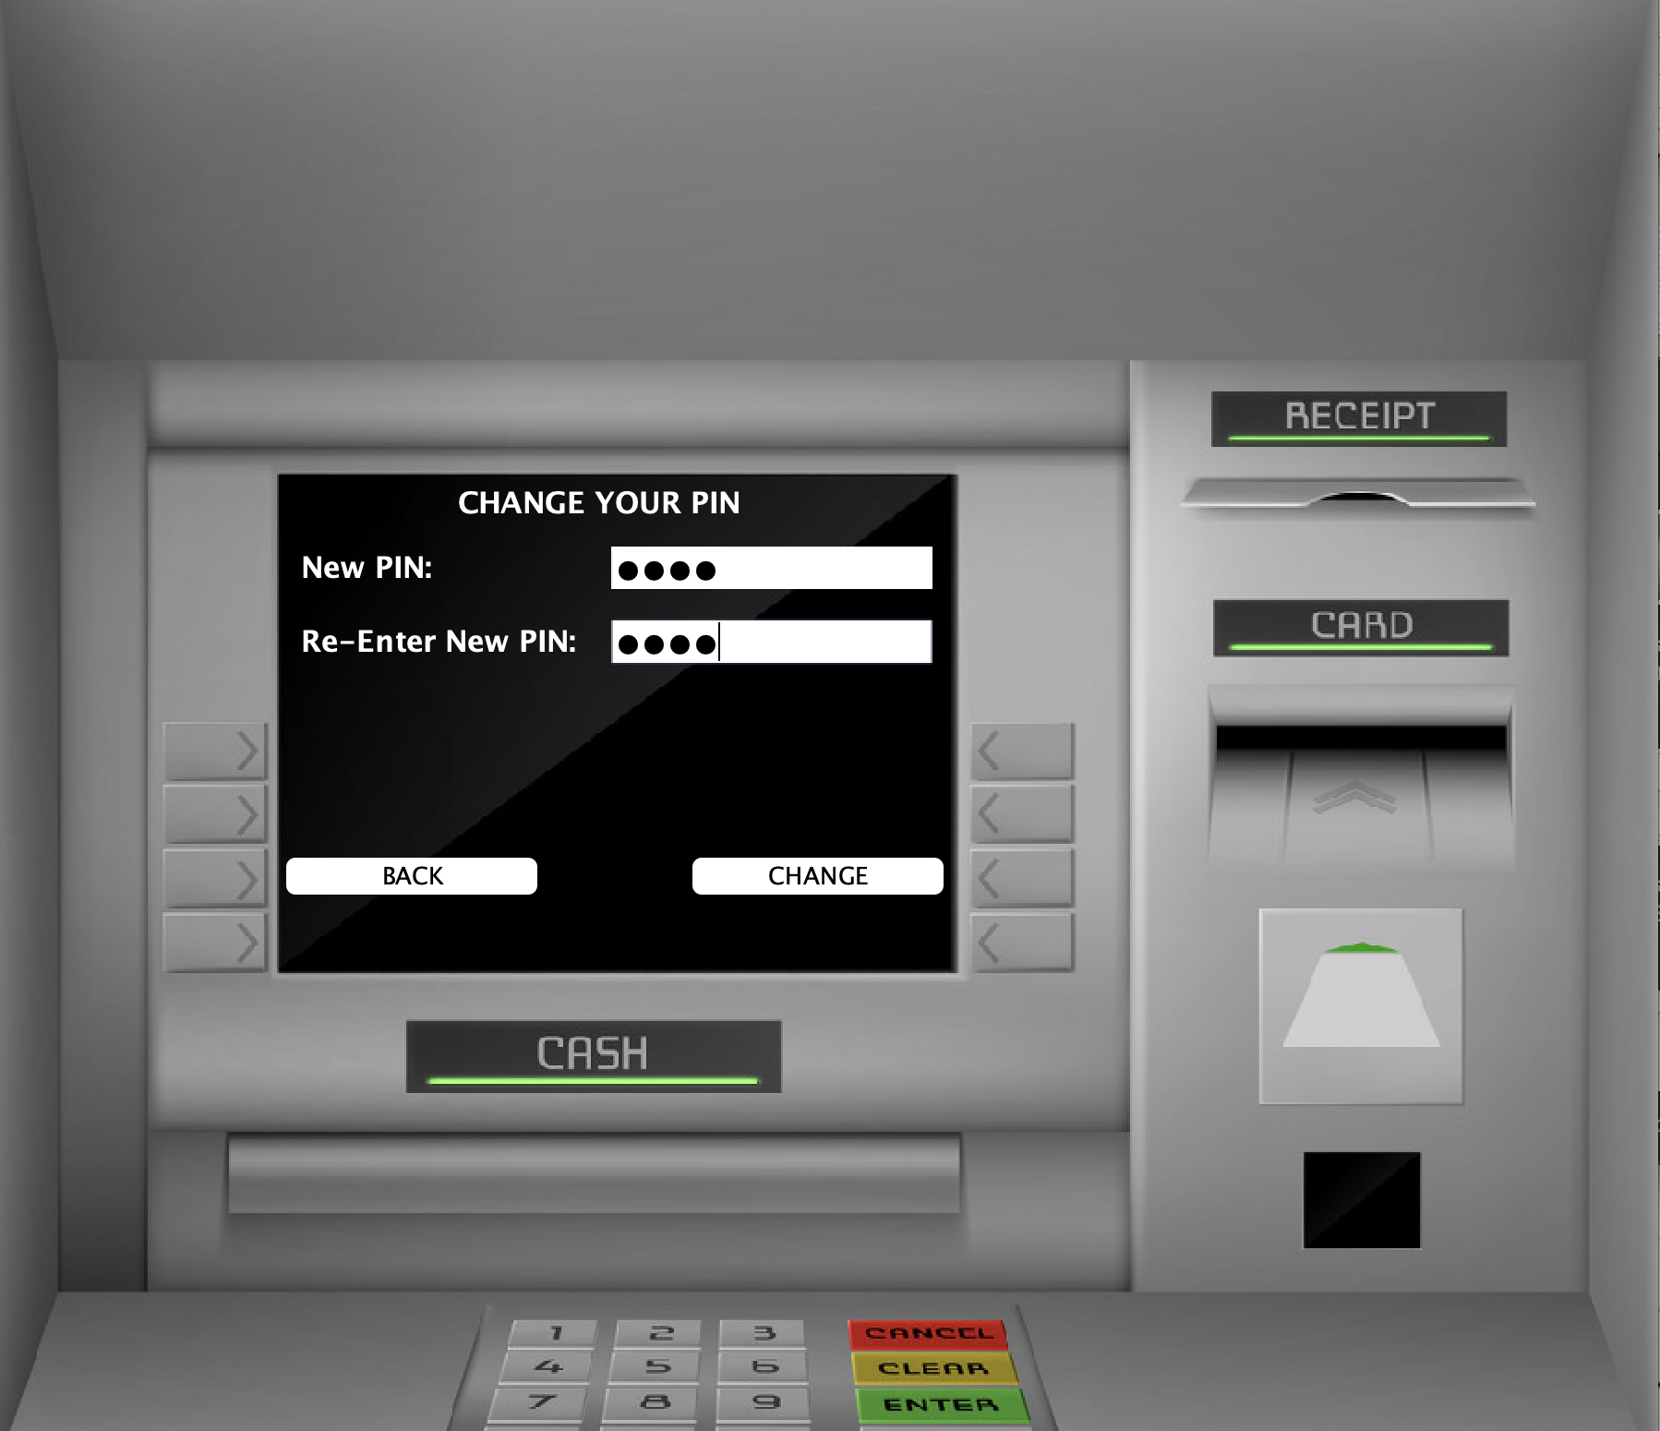

**PinChange class:**

**To change the current or randomly generated pin of a student account by user after login in can update the account pin by entering new pincode 2 times.**

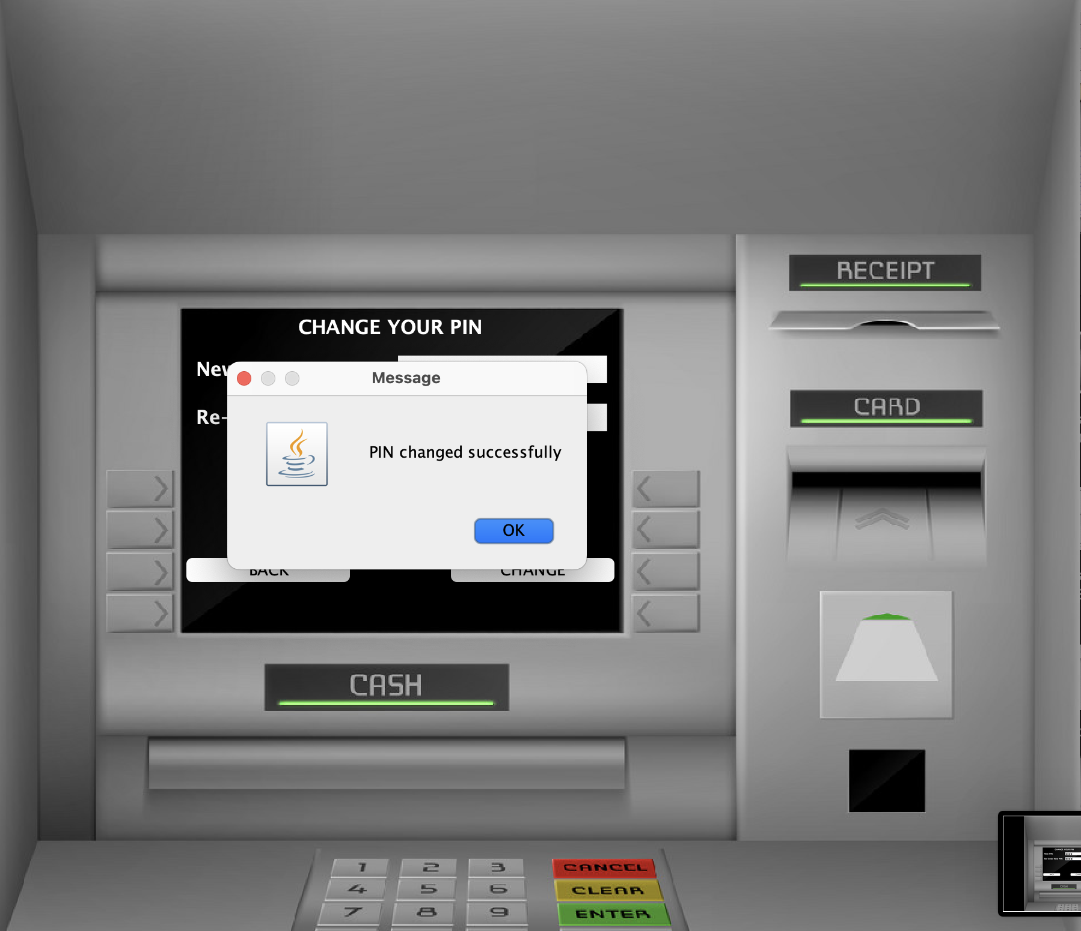

**PinChange class:**

**After clicking on change it will pop a message stating the pin changed successfully.**

**b. Module design and diagram for each module**

**1. User Authentication Module:**

- Classes and Responsibilities:

- `Login`: Manages authentication of users using credentials.

- `Signup(3)`: Handles the creation of new user accounts.

- `UserValidation`: Confirms the integrity of user credentials and enforces security protocols.

- Key Features:

- Implement multi-factor authentication for employees and administrators.

- Real-time input validation to ensure data integrity during sign-up.

- Secure handling and storage of sensitive information.

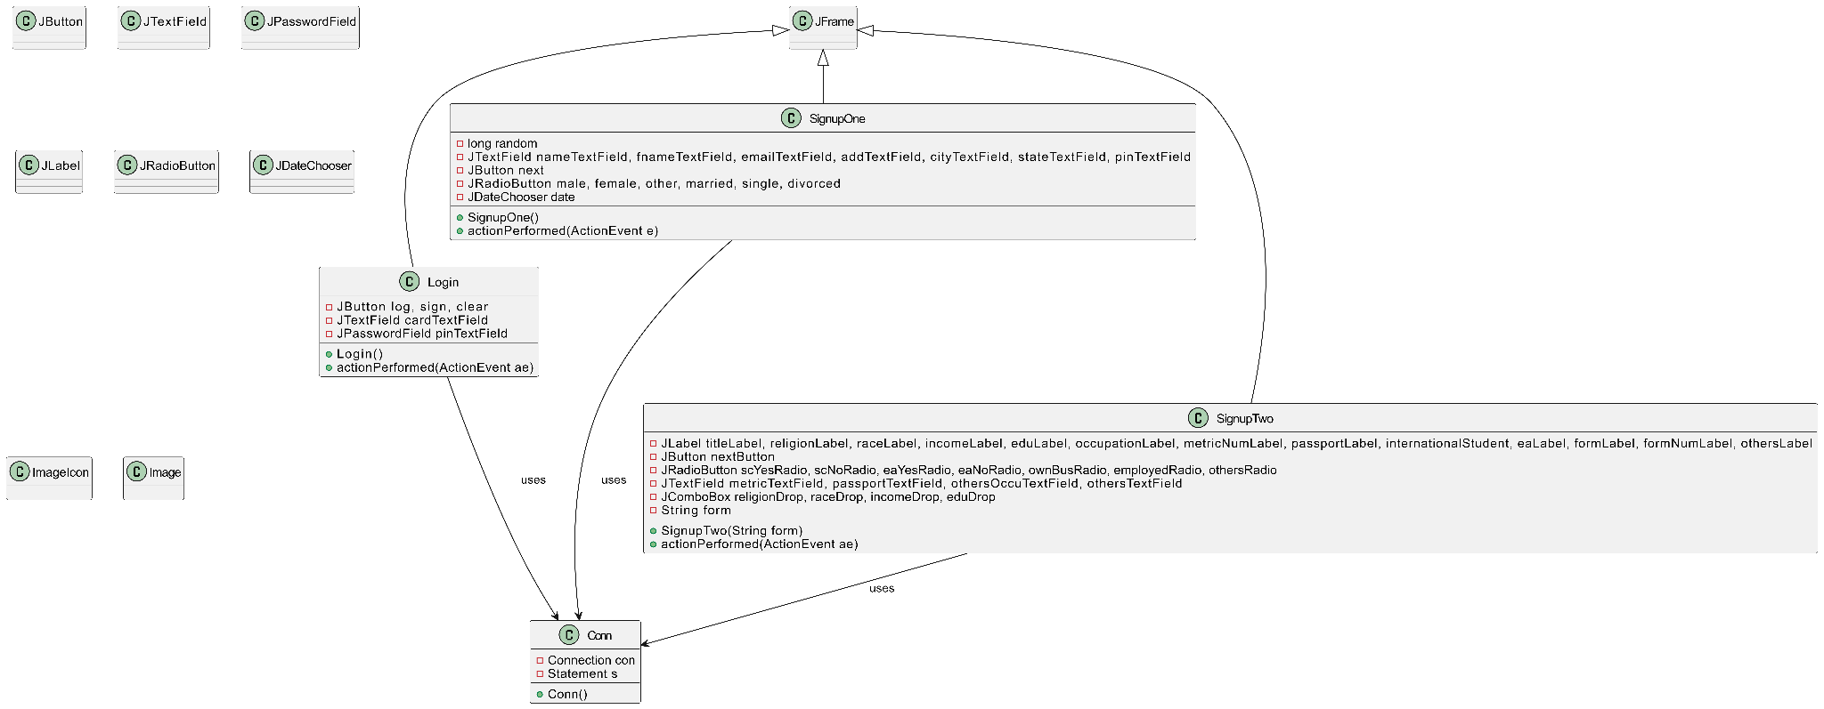

UML MODULE 1

**2. Account Management Module:**

- Classes and Responsibilities:

- `Mini statement`: Represents and manages account balance and transactions history.

-BalanceEnquiry: Show amount remaining in account.

- `PinChange`: Facilitates PIN updates while ensuring security.

- Card Number Generation: An automated system for generating unique and secure card numbers using a cryptographically secure random number generator.

- Account Types: Implementation of different account classes with specific features and rules for Savings and Current Accounts.

- Key Features:

- Automated card number generation for new accounts using secure algorithms.

- Support for multiple account types with distinct features and constraints.

- Real-time balance updates post any account activity.

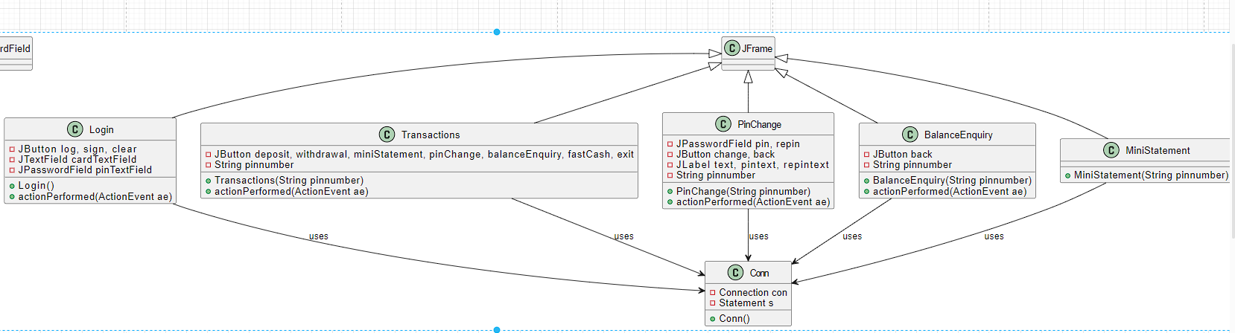

UML MODULE 2

**3. Transaction Processing Module:**

- Classes and Responsibilities:

- `Transaction`: Abstract class for common transaction properties and behaviors.

- `Deposit`: Specific class for handling deposit transactions.

- `Withdrawal`: Specific class for managing withdrawal transactions.

-FastCash: Specific class for withdrawing a preset amount.

- Key Features:

- Efficient processing of both deposit and withdrawal requests.

- Comprehensive transaction records for accurate auditing and reporting.

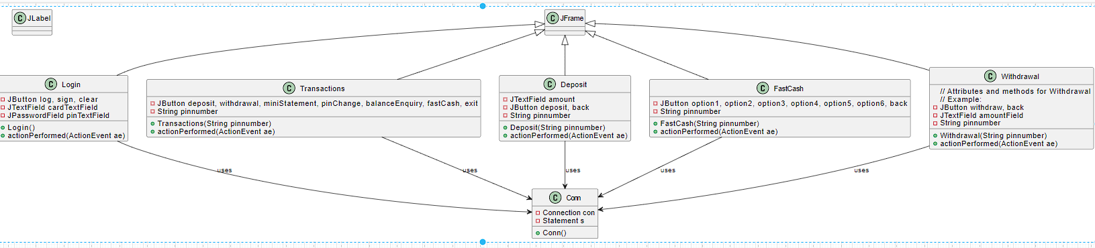

UML MODULE 3

**4. User Interface Module:**

- Classes and Responsibilities:

- `ATMInterface`: Controls the primary interaction layer for ATM transactions.

- `Screen`: Abstracts common functionalities of different screens in the ATM interface.

- Key Features:

- Intuitive and accessible UI for an easy navigation experience.

- Consistent and clear visual design across all screens.

**5. Database Connection Module:**

- Classes and Responsibilities:

- `DatabaseConnection`: Manages database connectivity and transactions.

- `AccountDAO`: Interfaces the application logic with database operations for accounts.

- Key Features:

- Reliable and secure database connections.

- Efficient data retrieval and storage with optimized queries. diagram shown above(conn class).

**5. Project Problems and Pitfalls**

The development and implementation of the University Bank Account Management System (UBAMS) involve complex processes and interactions. While aiming for a seamless and efficient system, several potential problems and pitfalls could arise. Addressing these challenges is crucial for the successful deployment and operation of UBAMS.

**1. Technical Challenges and System Integration**

- Complex Integration: Integrating UBAMS with existing university systems and banking networks is complex and may face compatibility issues.

- Scalability and Performance: Ensuring that the system scales effectively to handle peak usage times and a growing user base without performance degradation.

- Cybersecurity Threats: Continuous evolution of cybersecurity threats poses a significant risk. Maintaining state-of-the-art security measures is challenging and requires constant vigilance and updates.

**2. User Adoption and Interface Usability**

- Resistance to Change: Users accustomed to traditional banking methods may resist transitioning to a new system. Encouraging adoption requires strategic user education and marketing.

- Usability Issues: Designing an intuitive and user-friendly interface is critical. Poorly designed user interfaces can lead to low adoption rates and user dissatisfaction.

**3. Regulatory Compliance and Data Privacy**

- Compliance with Banking Regulations: Adhering to the myriad of banking regulations and standards, especially if the system handles international transactions.

- Data Privacy Concerns: Managing and protecting the vast amount of sensitive personal and financial data in compliance with global data privacy laws such as GDPR.

**4. Budget and Resource Constraints**

- Financial Limitations: Developing a comprehensive system like UBAMS requires substantial investment. Budget constraints can limit the scope of the project.

- **Resource Allocation**: Efficiently allocating human and technical resources to meet the project timeline without compromising quality.

**5. Maintenance and Support**

- Long-term Maintenance: Ensuring consistent long-term support and maintenance for the system can be resource-intensive.- Training and Support: Providing adequate training to staff and users, along with ongoing technical support, is essential for smooth operation but can be resource-demanding.

**6. Stakeholder Engagement and Expectations**

- Balancing Diverse Expectations: Aligning the system’s capabilities with the expectations of various stakeholders, including students, university administration, and financial partners.

- Effective Communication: Keeping all stakeholders engaged and informed throughout the development and implementation process is crucial but challenging.

**7. Future-Proofing the System**

- Adapting to Technological Advancements: Keeping the system updated with the latest technological advancements to remain relevant and efficient.

- Flexibility for Future Enhancements: Designing the system with enough flexibility to incorporate future updates and enhancements.

**8. Risk Management and Contingency Planning**

- Identifying Potential Risks: Systematically identifying and assessing potential risks associated with the project.

- Developing Contingency Plans: Establishing robust contingency plans for critical risks to minimize impact on the project.  
Conclusion, Recommendations, and Future Outlook for the University Bank Account Management System (UBAMS)

The University Bank Account Management System (UBAMS) project marks a significant advancement in the realm of digital banking, particularly tailored for the university sector. This initiative has been meticulously developed to nurture the diverse needs of its users, embedding a comprehensive suite of transactional functionalities. By facilitating a range of services from check deposits to online transactions, UBAMS stands as a versatile and user-centric platform.

**6.Conclusions, Recommendations and Future Works**

UBAMS has successfully revolutionized the banking experience for university students by integrating essential banking operations into a single, accessible online platform. It caters primarily to the youth and business-oriented individuals within the university, aligning with the dynamic and mobile lifestyle typical of this demographic. The project’s success is not just in its technological innovation but also in its adaptability to user needs and evolving banking trends.

The University Bank Account Management System (UBAMS) has been instrumental in transforming the banking experience for university students, successfully integrating a myriad of essential banking functionalities into a cohesive, online platform. Primarily catering to the unique lifestyle and financial needs of the youth and business-focused individuals within the academic community, UBAMS has seamlessly aligned with the dynamic, mobile-centric lifestyle prevalent in modern university settings. The success of UBAMS extends beyond its technological advancements; it reflects a deep understanding of user needs and the capacity to adapt to the rapidly evolving landscape of digital banking.

In terms of enhancements, several key recommendations are proposed to further refine the system. Firstly, an emphasis on strengthening customer support is crucial. This involves tailoring the support system to be more responsive and sensitive to the specific queries and challenges faced by students. A focus on improving the user interface is also recommended, ensuring continuous refinement of the website and mobile application interfaces to enhance intuitiveness and accessibility for users with diverse levels of digital proficiency. Additionally, there's a need for implementing comprehensive user training programs. These programs would play a pivotal role in facilitating a smoother transition for new users to digital banking, thereby enhancing user engagement with UBAMS. Moreover, actively soliciting and incorporating user feedback is essential. Establishing a robust feedback mechanism would contribute significantly to the continuous improvement of UBAMS, ensuring the system remains adaptable and responsive to the changing needs and expectations of its user base.  
Looking toward the future, UBAMS is poised for significant growth and expansion. Potential areas for expansion include scaling the system's reach internationally, which would involve extending a broader network of services such as ATMs and facilitating cross-border transactions. An essential component of future development is the creation of a comprehensive mobile application. This application would offer full banking functionalities, including secure login features and real-time updates, to provide users with a seamless and convenient banking experience on the go. Another crucial aspect of future growth is the integration of emerging technologies. Continuously incorporating advancements such as artificial intelligence for personalized banking services would ensure that UBAMS remains at the forefront of technological innovation in the banking sector. Additionally, diversifying the range of services offered by UBAMS is vital. This would involve including a wider array of banking services tailored to the university context, such as investment options and financial planning tools. Lastly, a commitment to sustainable and inclusive banking practices is paramount. By embracing global trends towards sustainability and social responsibility, UBAMS would not only enhance its service offerings but also contribute positively to broader societal and environmental goals.

**7.Reference**

1. Online Bank Account Management System

Website: http://www.slideshare.net (Collect some info for report documents)

2. Learning MYSQL, JavaScript, jQuery, PHP, HTML, CSS3,

Website: http://www.w3schools.com

3. PHP and MySQL video tutorials

Website: http://www.freehinditutorial.com, http://www.youtube.com

4. Veneeva, V. (2006), “E-Banking (Online Banking) and Its Role in Today's Society”,

Ezine articles